Biology Forum

Please join us for the next Biology Forum speaker
Dr. Aldemaro Romero Jr., Baruch College, City University of New York

When: Friday March 22, 12:00 p.m.
Where: UHO 145

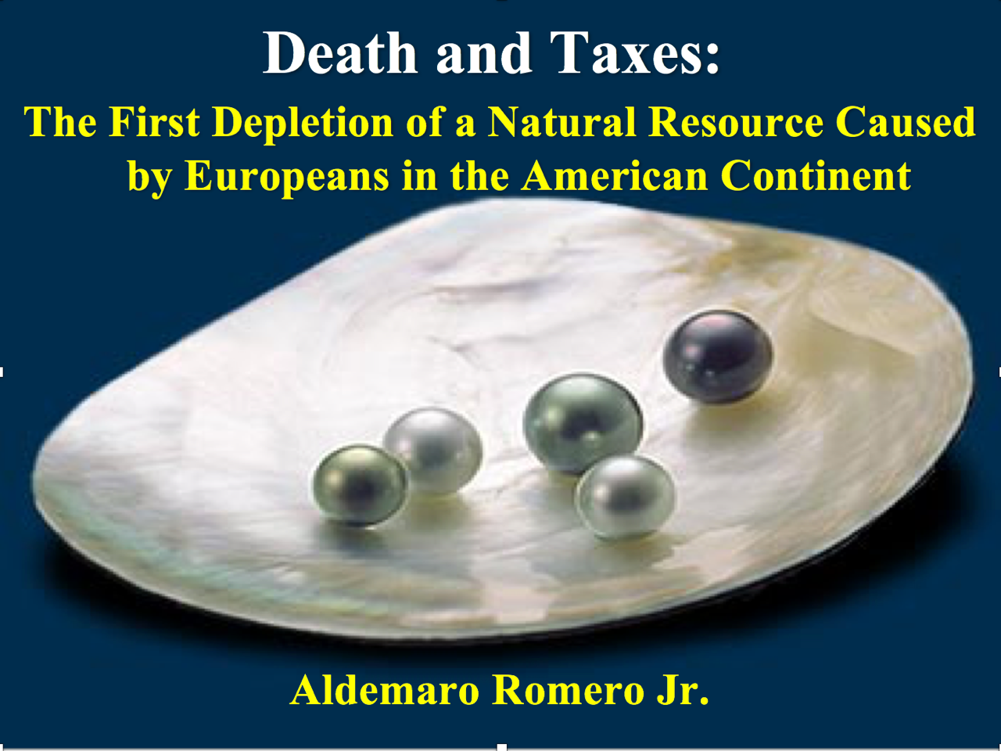

Interdisciplinary approaches can be used not only to interpret past patterns of natural resource utilization but also to provide useful tools for conservation biology and resource management. Pearls were a primary natural resource exploited early by the Spaniards in America. The depletion of the pearl oyster (Pinctada imbricata) beds off the coasts of the island of Cubagua, Venezuela, in the sixteenth century and its replacement by the turkey-wind mussel (Arca zebra), was a swift process. Using tax data, we can conclude that such a rapid depletion was the result not only of overexploitation in a short period but also the local ecological characteristics. Under conditions of environmental stress generated by overfishing, the turkey-wing mussel outcompeted the pearl oyster, thus preventing its recovery. The exploitation of the pearl oyster beds directly influenced the demographic, social, and cultural conditions of the indigenous human population in the Caribbean.
.

Aldemaro Romero Jr. is the Weissman Dean of Arts and Sciences at Baruch College in New York. He received his bachelor’s degree in Biology from the University of Barcelona, Spain, and his Ph.D. in Biology from the University of Miami, Florida. He has published more than 1,000 pieces including more than 30 books and monographs. His academic interests range from environmental to evolutionary biology, to history and philosophy of science, to science communication and higher education. He has received numerous grants as well as prizes for his research and science communication work.

